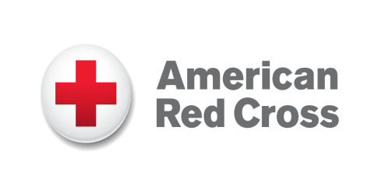

American Red Cross
Executive Director
Cheyenne, Wyoming

We are currently seeking a professional, innovative and enthusiastic Executive Director for our Wyoming Region located in Cheyenne.
As one of the nation’s premier humanitarian organizations, the American Red Cross is dedicated to helping people in need throughout the United States and, in association with other Red Cross networks, throughout the world. We depend on the many generous contributions of time, blood, and money from the American public to support our lifesaving services and programs. If you share our passion for helping people, join us in this excellent career opportunity.

This highly visible role leads and directs volunteers and employees in the Wyoming Chapter to ensure the American Red Cross goals and mission are achieved. Reporting to the Regional Executive, you will promote an inclusive, team-based culture centered on leading and empowering volunteers. As the face of the Red Cross, this role also cultivates and manages select donors. In addition to enhancing community presence through key media and community partner relationships, you will steward the local board of directors.

Responsibilities:

- Recruit and develop local volunteer leaders to achieve mission metrics and support responsibilities in home market and district.
- In support of fundraising, manage local United Way relationships, local major donors, and board of directors’ contributions.
- Work with board to nurture individual, corporate, and foundation donors.
- Build community presence in home market through relationship with media, elected officials, and key governmental partners.
- Develop relationships with community stakeholders. Focus especially on those that bridge volunteer partners such as faith-based, college/university, NGO/NPO, and community organizations.
- Recruit and steward local board of directors for 100% participation. Manage annual board campaign and efforts of other related community boards.

Qualifications:

Education: Four year college degree (BS/BA) in Business, Communications, Marketing, Public Relations, Finance or non-profit administration or equivalent experience required. Prefer Master’s degree in the field of community organization, public or business administration or non-profit management.

Experience: Minimum of five years related experience. Demonstrated ability to exercise good and timely judgment in complex situations. Demonstrated ability for strong communications and influencing skills along with public speaking and writing. Demonstrated ability to develop and implement fundraising strategies. Demonstrated ability to build and sustain community relationships/partnerships Proven experience in influencing others and building relationships.

Management Experience: At least three years of related management and supervisory experience. Experience working in an environment requiring flexibility and managing change.

Successful candidate must have demonstrated ability with fundraising and revenue generation goals, to include ability to develop and implement fundraising strategies.

Other: Proficient with MS Office software, including Word, Excel, PowerPoint and Outlook. Familiarity with federal state and local employment laws.

Travel is required within the counties.

The American Red Cross is a nonprofit organization that offers employees growth and development; team spirit; a competitive salary; and a comprehensive benefits package.

The American Red Cross is an Equal Opportunity/Affirmative Action employer. All qualified applicants will receive consideration for employment without regard to sex, gender identity, sexual orientation, race, color, religion, national origin, disability, protected veteran status, age, or any other characteristic protected by law.

Apply now! Joining our team will provide you with the opportunity to make a difference every day.

Visit our career site to apply:

https://americanredcross.wd1.myworkdayjobs.com/American_Red_Cross_Careers/job/Cheyenne-WY/Executive-Director_RC27090

