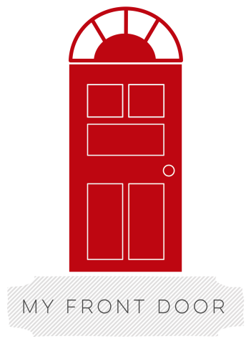
Mailing Address
P.O. Box 21682
Cheyenne, WY 82003
My Front Door [Cheyenne]
Aspen Ridge Office Building
2232 Dell Range Blvd. Suite 304
Cheyenne, WY 82009
(t) 307.514.5831
My Front Door [Laramie]
302 S. 2nd St. Suite 212
Laramie, WY 82073
(t) 307.745.4130
www.myfrontdoor.org

POSITION DESCRIPTION FOR: ALBANY COUNTY FAMILY ADVOCATE

Essential Job Functions
Coordinates with Lead Family Advocate to:

- Engage the community through outreach to include:
  - Community events
  - Agency and partner presentations as necessary
  - Partner support

- Develop, coordinate, update and monitor an active social media campaign for both counties to include:
  - Face book
  - Twitter
  - LinkedIn
  - Instagram

- Create a pipeline of participants through:
  - Consistent recruitment efforts
  - Appropriate screening
  - Continued partner relations

- Provide case management:
  - Intake screening and community or resource referral
  - Assist clients in establishing SMART Goals
  - Family financial planning education and responsibility coaching
  - Monitor, coach, and counsel participants in reaching goals

- Deliver Instruction:
  - Coordinate class instruction at regular intervals
  - Secures location
  - Ensures participant meet requirements for program completion certificate

- Represent home buyers by ensuring compliance with;
  - HUD Home Inspections
  - Home closing procedures and documents
  - Fiduciary requirements
  - Accompanying at closing

Qualification Guidelines
• Technical Knowledge: considerable knowledge and experience of CDBG/HOME/CHDO/HUD programs and their requirements, including applicable federal, state and local laws, rules and regulations.
• Presentation Skills: Polished and refined presentation skills to convey program requirements, future goals, and accomplishments to Municipal officials, CHDO’s and their professional teams.
• Computer Skills: basic computer skills including familiarity with Microsoft Office Suite.
• Organizational/Planning Skills: requires a high degree of organizational skills and advance planning/ tracking to participants with the support and knowledge to be successful home owners.
• Time Management Ability: Skilled in effectively working with multiple clients and their time sensitive goals and education structure.
• Interpersonal Skills: Foster and maintain trust, partnerships and effective working relationships with participants, members of the community and internal staff.
• Customer Service Skills: Excellent customer service skills in communicating and providing technical assistance to community based organizations.
• Communication Skills: Superior oral and written communication skill and a fundamental understanding of professional and social media accepted practice.

EDUCATION AND EXPERIENCE
Associate’s degree in Human Services, Psychology or Social Work OR 2 years experience in affordable housing and case management. Preference will be given for candidates with a certification in: HUD Housing Counselor Certifications, Neighborworks Housing Counselor Certification and Neighborworks Train the Trainers Certification, or significant progress toward certification completion.

SALARY RANGE: $31,200 - $33,280

