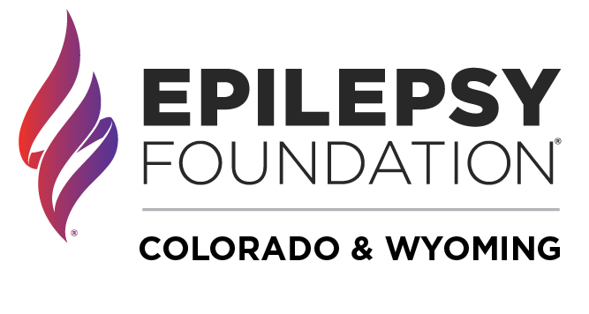
Outreach & Engagement Manager, Wyoming

Job Description

ABOUT THE EPILEPSY FOUNDATION OF COLORADO & WYOMING:
Three simple words define the Epilepsy Foundation of Colorado & Wyoming: Connecting, Educating, and Empowering. We connect people to healthcare providers, support networks, and a listening ear. We educate schools, employers, and the community at large, to reduce stigma and raise awareness. And we empower people affected by epilepsy with knowledge, resources, and advocacy to live their best lives.

The Position:
The Epilepsy Foundation of Colorado & Wyoming is seeking a part-time Outreach & Engagement Manager based in Wyoming.
The Foundation expanded its reach into Wyoming in Summer 2021 and this position will be the key team member tasked with engaging and educating a wide variety of audiences including but not limited to: individuals and families affected by epilepsy, healthcare providers, community partners, event participants, corporate partners, legislators and others.

Reporting to and working closely with the Director of Community Initiatives, the Outreach & Engagement Manager will be responsible for connecting with individuals, nonprofit organizations, companies, and others with the goal of educating the public about epilepsy, engaging the community in the programs and services of the Foundation and raising funds to support our mission. This position will support the successful execution of the Foundation’s core programs and events, including seizure first aid training, support groups, committee meetings, social gatherings, and providing on-site support for fundraising events. Duties also include recruiting & engaging event participants, teams and volunteers. As Outreach & Engagement Manager, you will play a pivotal role in the success and growth of the Epilepsy Foundation into Wyoming, ensuring that the organization thrives and is positioned to serve the estimated 5,000 people in Wyoming who are living with epilepsy.

Core Responsibilities:

Education and Awareness
- Responsible for marketing National Epilepsy Foundation Seizure First Aid Certification, School Personnel and School Nurse webinars to the school professionals and community. Work in partnership with National Epilepsy Foundation to market and track participation.
- Develop partnerships with the Wyoming School Nurse Association, Wyoming Department of Education, local schools and community professionals/organizations to promote relevant school and SFA trainings.

Volunteer Management
- Identify appropriate volunteer leaders and members to form an Adult Volunteer Leadership Group (We C.A.R.E.) to provide support and connection to adults affected by epilepsy as well as raise awareness for the local epilepsy community.
- Develop and manage Support Groups online and in-person by recruiting, training, and supporting volunteer group leaders across the state.
- Ensure quality programming of support groups through educational and social content.
- Serve as lead staff member for a WY-based Walk committee and manage day-of-event volunteers for WY Walk.
Intervention, Assessment, Care Navigation & Referral
- Become and remain informed about the local resources for people with epilepsy, including community, medical and mental health resources.
- Provide navigation support to individuals contacting the Foundation. Connect individuals and families to Foundation or community resources as appropriate.
- Expertly assess mental health concerns of individuals, as well as level of urgency, and provide or refer to the appropriate level of care.
- Cultivate strategic partnerships with outside service providers, agencies, and other resources in the community.
- Maintain accurate documentation of client contact.

Fundraising
- Identify committee leaders and participants with which to launch the Walk to END EPILEPSY campaign in Wyoming in small communities across the state.
- Manage the annual Wyoming Gives Day campaign.
- Support fundraisers in various Do-It-Yourself (DIY) events and third-party fundraising activities in Wyoming.

Legislative Advocacy
- Help identify and lead advocacy initiatives that are in line with the mission of the Foundation.
- Work with National Epilepsy Foundation on advocacy efforts, such as Seizure Safe Schools bill.
- Identify and work with key volunteers on advocacy-related projects.
- Build partnerships with the other organizations, voice support for initiatives that are in line with the mission of the Foundation and participate in collaborative efforts when appropriate.
- Stay abreast of legislative issues that affect the epilepsy community.
- Build and maintain partnerships with state and federal legislators in order to create an epilepsy presence and voice in the legislative process.

Marketing
- Identify and attend outreach opportunities such as health fairs, sports expos, education festivals, other community groups
- Contribute to the Foundation’s online and social media strategy with an eye to engaging the Wyoming community via email, the website, monthly newsletter and various social media channels.

Other
- Understand and effectively utilize the Foundation’s database (Salesforce) and fundraising platforms to evaluate trends., produce reports and improve processes
- Enthusiastically collaborate with a cross-functional team to accomplish goals
- Other duties as assigned

Requirements/Qualifications:

- Home based (Laramie, Casper, Cheyenne preferred but other Wyoming locations considered)
- Deep and authentic knowledge of the culture and communities of Wyoming
- Highly polished, outgoing self-starter with the ability to work both independently and collaboratively with colleagues, volunteers, fundraisers, and sponsors in a professional and enthusiastic manner.
- Superior project-management skills, with well-organized and demonstrated abilities to manage multiple priorities and programs simultaneously.
- Energized by people and events
- Excellent written and verbal communication skills.
- Ability to work flexible hours including nights and weekends
- Ability to work remotely from any community in Wyoming
- Bachelor’s Degree required.

Compensation & Benefits:
- This is a part-time, 20 hours per week position, days and times flexible.
- Hourly compensation is $25 per hour.
- Due to the nature of this position, it is not eligible to receive benefits.

CONTACT:
Marcee Aude MA
Director of Community Initiatives; Epilepsy Foundation of Colorado & Wyoming
marcee@epilepsycolorado.org

