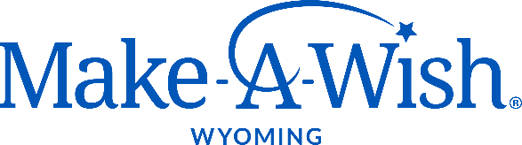

JOIN OUR TEAM!

Make-A-Wish® Wyoming works to grant the wishes of children battling critical illnesses across the state of Wyoming. Together, we can transform lives one wish at a time.

POSITION: Director of Development

JOB SUMMARY
The director of development is responsible for the overall development strategy for Make-A-Wish® Wyoming, including donor stewardship and cultivation, event coordination and execution. The director of development works to increase the organization's visibility and funding to achieve continued mission growth, by providing development support and tools in an efficient, effective, and sustainable manner. Beyond coordinating internal events and managing external events, the director of development is also in charge of stewarding and cultivating current donor base, tracking donor information, and developing a diversified funding portfolio. Reporting to the chapter CEO, the director of development performs the following functions, in brief:

RESPONSIBILITIES
- Create and execute the chapter’s development plan to support overall planned growth, leveraging Make-A-Wish America’s marketing strategy and tools
- Develop various funding platforms including online, peer to peer, Kids for Wish Kids®, annual appeals, internal and external events, grants, planned giving and major gifts initiatives
- Optimize the marketing and promotion of signature and other fundraising events by coordinating with the Communications Manager (e.g. Stories of Light® Gala, Tour de Wish, World Wish Day, and other external events)
- Manage all external events including processing fundraising agreements, providing necessary tools and resources, and stewarding relationships
- Develop and execute a donor stewardship plan, steward and cultivate existing and potential donors, engage with donors and supporters in a meaningful way
- Work closely with the Volunteer Manager to coordinate volunteers for event related activities
- Perform other duties as required or assigned

REQUIRED SKILLS & ABILITIES
- Proven team leadership and ability to work in a team environment
- Experience designing and executing creative and strategic development programs
- Experience coordinating and executing events
- Excellent relationship building skills, experience in building donor relationships
- Exceptional written, verbal and public speaking communication skills
- Excellent organizational, time and project management skills
- Positive attitude, compassionate with ability to maintain confidentiality
- Customer-service oriented
- High energy, enthusiastic and competent working with a diverse group of staff, wish families, volunteers, board members and donors
- Mission focused with the desire to make a difference
- Skilled in Microsoft Office Suite

PREFERRED SKILLS & EDUCATION
- 3+ years of development and fundraising experience in a non-profit setting
- Proven track record of building and sustaining donor relationships
- Experience with Blackbaud’s Raiser’s Edge, or similar database platform a plus
- Non-profit work experience

JOB LOCATION
Casper, WY

POSITION TYPE
Full-Time
Hourly, DOE
Benefits include vacation, health insurance, dental insurance and SIMPLE IRA match

Please submit your cover letter and resume to:

Make-A-Wish® Wyoming
PO BOX 273
Casper, WY 82602

Or e-mail to info@wyoming.wish.org

