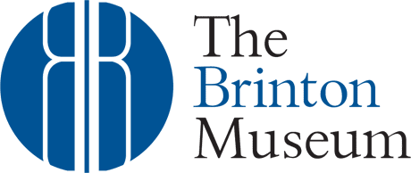
Job opening
Development Officer, Membership and Sponsors
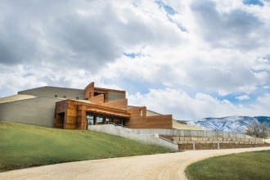
Unique career opportunity to be a part of the team at The Brinton Museum, located on the beautiful 620-acre historic Quarter Circle Ă Ranch in Big Horn, Wyoming. The Brinton Museum is a multi-faceted institution with a mission to connect the past, present and future of the American West through its historic Quarter Circle A Ranch, Fine Art, and American Indian Art Collections.

The vision of The Brinton Museum is to expand upon the work of Helen Brinton, who in 1960 established an institution named after her brother Bradford. Helen’s intent was to preserve the Quarter Circle Ă Ranch and the Brinton collection of fine art, furnishings, historic and American Indian artifacts and make them accessible to the public. It was her desire that the institution be a source of education and enjoyment to all visitors, regardless of nationality, race, color or creed.
POSITION SUMMARY: The Development Officer works closely with both the Development Director and Director of Operations in furtherance of The Brinton Museum’s resource development goals. The Development Officer is responsible for building and maintaining relationships with museum patrons, members and corporate sponsors with an aim toward optimizing resource development opportunities and community engagement.
ESSENTIAL DUTIES AND FUNCTIONS:
- Tells the Museum’s story, comprehends its mission, participates in programs and events, and makes connections with the museum’s patrons to answer their questions and elicit their feedback. Interacts with other members of the museum’s staff to share information and to collaborate to achieve the museum’s strategic objectives
- Develop and execute the membership and corporate sponsorship components of the organization’s annual resource development plan
- Strengthen the museum’s donor pipeline and prospects through the cultivation of relationships with museum patrons and members
- Cultivate and manage relationships with existing and prospective corporate sponsors and partners
- Oversee the creation and distribution of the bi-monthly digital newsletter to museum members and constituents
- Create content for print and digital marketing relating to members and sponsorship recognition
- Assist Development Director with the planning and execution of donor cultivation, solicitation and appreciation events, including the annual Gala
- Oversee the development and use of online forms used to generate revenue on the website
- Assist Development Director with the oversight of the Donor Perfect database, including entry and maintenance of accurate membership and corporate sponsorship data
- Attend museum events to meet and network with members, patrons and sponsors
- Performs all other related duties as assigned by management.

DESIRED EDUCATION AND EXPERIENCE:
- Bachelor’s degree and 2 years’ fundraising experience (preferred) or an equivalent combination of education and experience

QUALIFICATIONS AND SKILLS:
- Excellent oral and written communication
- Attention to detail
- Demonstrated experience in fundraising
- Strong interpersonal skills
- Demonstrated relationship management experience with the ability to initiate and grow mutually beneficial relationships
- Ability to organize time, balance many priorities and work in an effective manner
- Results-oriented, organized, and able to meet deadlines
- Analytical thinking skills and a strong sense of initiative
- Proficient skill with donor databases, DonorPerfect experience desired
- Proficient skill with Microsoft Office products and Google Workspace

COMPENSATION AND BENEFITS:
Annual salary based on qualifications. 403(b) plan with matching from employer, employee discount, health insurance, and paid time off.

Qualified candidates please email cover letter and resume to kheimbuck@thebrintonmuseum.org

For questions regarding the position please contact Kendra Heimbuck at 307-763-5928

To learn more about The Brinton Museum go to thebrintonmuseum.org

