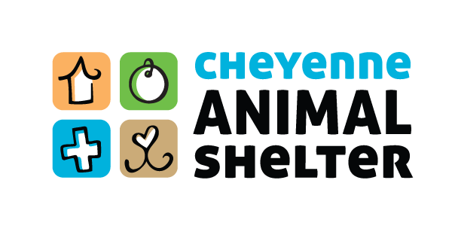

Branding & Communications Manager

Job Title: | Branding & Communications Manager
Department: | Fundraising - 02
Job Classification: | Full-time, exempt, salary
Job Relationships: | Reports to CEO  This position has no direct supervisory authority.  This position will be required to work with across departments to coordinate messaging, timelines, and content. Frequent interactions with other staff, volunteers, members of the Board of Directors, and the public should be expected.  Is a member of the organization’s Operations Management team.

The Branding & Communications Manager is responsible for telling the organization’s story. The incumbent will manage the organization’s external communications across a variety of digital and printed media platforms and will lead media relations, serving as the organization’s spokesperson. Responsible for creating and executing a dynamic communications strategy in line with broader strategic goals and objectives, promoting and preserving the integrity of the organization’s branding, and producing high-quality, engaging photo, video, and copy-written content. Additionally, as part of an effort to grow our online giving program, the incumbent will be responsible for growth of the organization’s monthly, recurring donor program.

Other duties may include participation in event planning and execution, helping to photograph adoptable pets, and assisting with creating high-quality presentation materials as needed.

Major Duties and Responsibilities:

Responsible for telling the organization’s story in the furtherance of broader strategic goals and objectives
- Work across departments to align messaging strategy with annual goals and agency activity, defining an annual integrated communications calendar that incorporates digital and traditional media, internal communications, website content, printed materials, branded merchandise, and media communications.
- Take photos and create videos to assist in telling the organization’s stories
- Manage the organization's social media platforms with dynamic content helping to build the reputation, visibility, and knowledge of its expertise, programs, and services.
- Helps to design, map, update and maintain the website
- Increase social media followers, website traffic, and e-newsletter subscribers
- Guide and lead staff in the creation of original, educational content to be delivered to the public in the form of webinars, town hall-style presentations, and blogs.
- Design collateral marketing & communications material (annual report, printed and e-newsletters, flyers, brochures, social media graphics, merchandise, etc) in the brand identity

Media Relations
- Lead media relations, including serving as a spokesperson, writing press releases, scheduling and handling interviews and press conferences
- Develop and maintain a comprehensive list and relationships with, local and regional media contacts

Fundraising Responsibilities
- Assist in developing programs and incentives for community partner engagement and recognition
- Enhance visibility of and grow the monthly recurring donor program through online giving
- Manage the online giving portion of the organization's annual campaign, specializing in small gifts and growing the number of new, individual donors
- Assist in the planning & execution of fundraising events

Budgeting & Financial Management
- Annually provides budget recommendations for departmental need, including: media buys, paid social media promotions, replacement of branded merchandise and material, etc.
- Tracks departmental spending and provides regular financial reporting regarding expenses

Reporting & Success Metrics

- Establishes program goals and key performance indicators, tracks performance metrics and employs knowledge, tools, and resources as necessary to achieve and maintain program goals.

Other duties as assigned

Job Qualifications
Education and Experience:
- Bachelor’s Degree or equivalent applicable experience
- Five or more years of graphic design, copy-writing, journalism, marketing, sales, branding strategy or related field
- Proficient in the use of Google Suite, Wordpress, Squarespace, Photoshop, Indesign, and Illustrator.

Knowledge, Skills, Abilities
- Strategic planning
- Teamwork and communications skills
- Copywriting
- Graphic design
- Media relations
- Social Media management
- Data analytics and reporting
- Google ads
- Content creation
- Photography and videography and editing
- Time management
- Project management
- Interacting with the public
- Understanding of content marketing strategy
- Able to work a flexible schedule, including occasional evening and weekend shifts, as required

Working Conditions:
Work Environment: Most work is performed in normal shelter and office setting. Computer use up to eight hours a day; exposure to high noise levels, zoonotic diseases, and animal bites/scratches when handling animals. Potential exposure to dangerous/fractious animals. Exposure to cleaning agents; exposure to all weather conditions; Most work is performed in normal shelter or office setting; Occasional weekend and evening work as required.

Physical Activities: Occasional lifting and carrying of up to 50 pounds without assistance and more with assistance. Frequent computer use. Potential for standing, walking, sitting up to eight hours or more per day; Bending, reaching, squatting, kneeling, pulling, pushing, cleaning; Driving a car or large service vehicle.

Note: Must be at least 21 years of age; must hold a valid Wyoming Driver License and have and maintain an insurable driving record.

